IMPLEMENTING CRM FOR RESULT TRACKING OF A CANDIDATE WITH INTERNAL MARKS (DEV)-(SHORT –TERM)

**Team ID :** LTVIP2023TMID11579

**Team Leader :** N KARTHIK

**Team member :**  s mohan

**Creation Of Auto Number Field On Candidate Object, Number Field On Course Details Object & Formula Field Course Details Object**

Let’s create a Number field on Course Details object

1. Click the gear icon and select Setup. This launches Setup in a new tab.

2. Click the Object Manager tab next to Home.

3. Select Course Detail.

4. Select Fields & Relationships from the left navigation

4. Click New & select number field, click Next

6. For Field Label Duration, enter.

7. Give Help Text- Enter Course duration value in Years

8. Click Next, Next, then Save & New.

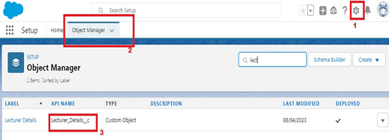

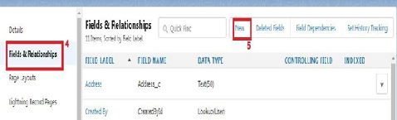

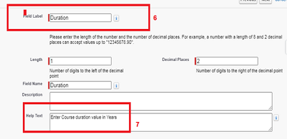

Now Let’s create a Formula field on Internal Results object

1. Click the gear icon and select Setup. This launches Setup in a new tab.

2. Click the Object Manager tab next to Home.

3. Select Internal results.

4. Select Fields & Relationships from the left navigation.

5. Click New

6. Select the Formula as the Data Type, then click Next.

7. Give field label Candidate Roll Number

8. Select formula return type text, Click Next

9. Click Insert Field

10.Create and insert formula Candidate r.Candidate_Roll_Number   c, and then click Insert.

11.Click Next, Next, then Save.





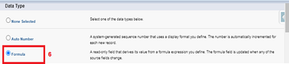

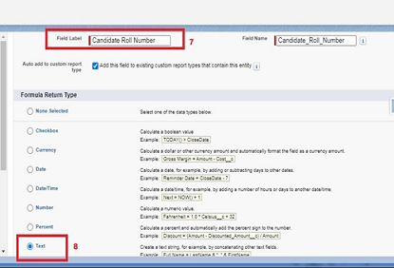

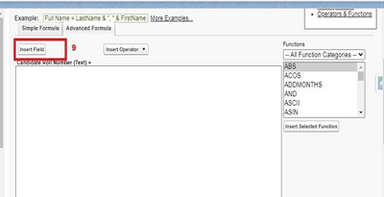

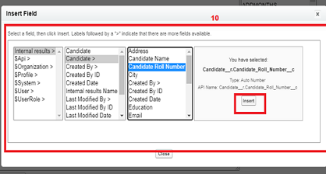

Now Let’s create an auto number field on Candidate object

1. Click the gear icon and select Setup. This launches Setup in a new tab.

2. Click the Object Manager tab next to Home.

3. Select Candidate.

4. Select Fields & Relationships from the left navigation

5. Click New

6. Select the Auto Number as the Data Type, then click Next.

7. For Field Label Candidate enter Roll Number.

8. Give a display format

9. Click Next, Next, then Save & New.





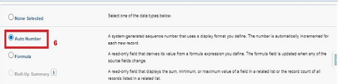

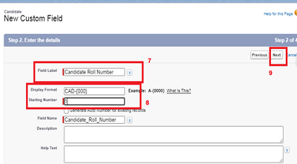

**Creation Of Auto Number Field On Candidate Object, Number Field On Course Details Object & Formula Field Course Details Object**

Let’s create a Number field on Course Details object

1. Click the gear icon and select Setup. This launches Setup in a new tab.

2. Click the Object Manager tab next to Home.

3. Select Course Detail.

4. Select Fields & Relationships from the left navigation

4. Click New & select number field, click Next

6. For Field Label Duration, enter.

7. Give Help Text- Enter Course duration value in Years

8. Click Next, Next, then Save & New.

Now Let’s create a Formula field on Internal Results object

1. Click the gear icon and select Setup. This launches Setup in a new tab.

2. Click the Object Manager tab next to Home.

3. Select Internal results.

4. Select Fields & Relationships from the left navigation.

5. Click New

6. Select the Formula as the Data Type, then click Next.

7. Give field label Candidate Roll Number

8. Select formula return type text, Click Next

9. Click Insert Field

10.Create and insert formula Candidate r.Candidate_Roll_Number   c, and then click Insert.

11.Click Next, Next, then Save.









Now Let’s create an auto number field on Candidate object

1. Click the gear icon and select Setup. This launches Setup in a new tab.

2. Click the Object Manager tab next to Home.

3. Select Candidate.

4. Select Fields & Relationships from the left navigation

5. Click New

6. Select the Auto Number as the Data Type, then click Next.

7. For Field Label Candidate enter Roll Number.

8. Give a display format

9. Click Next, Next, then Save & New.



**Delete Record (Course Details)**

Deleting Records of Course Details Object

1. Click on App Launcher on left side of screen.

2. Search Candidate Internal Result Card & click on it.

3. Click on Course details Tab.

4. Click on Arrow at right hand side on that Particular record.

5. Click delete and delete again.

